UNITED STATES
SECURITIES AND EXCHANGE COMMISSION
Washington, D.C. 20549

FORM 8-K

CURRENT REPORT

Pursuant to Section 13 or 15(d)
of the Securities Exchange Act of 1934

Date of Report (Date of earliest event reported): August 11, 2026

HARVARD BIOSCIENCE, INC.
(Exact name of registrant as specified in its charter)

Delaware | 001-33957 | 04-3306140
(State or Other Jurisdiction of Incorporation) | (Commission File Number) | (I.R.S. Employer Identification No.)

84 October Hill Road
Holliston, MA 01746
(Address of Principal Executive Offices) (Zip Code)

(508) 893-8999
(Registrant's telephone number, including area code)

(Former name or former address, if changed since last report)

Check the appropriate box below if the Form 8-K filing is intended to simultaneously satisfy the filing obligation of the registrant under any of the following provisions:

 | ☐ | Written communications pursuant to Rule 425 under the Securities Act (17 CFR 230.425)

 | ☐ | Soliciting material pursuant to Rule 14a-12 under the Exchange Act (17 CFR 240.14a-12)

 | ☐ | Pre-commencement communications pursuant to Rule 14d-2(b) under the Exchange Act (17 CFR 240.14d-2(b))

 | ☐ | Pre-commencement communications pursuant to Rule 13e-4(c) under the Exchange Act (17 CFR 240.13e-4(c))

Securities registered pursuant to Section 12(b) of the Act:

Title of each class | Trading Symbol(s) | Name of each exchange on which registered
Common Stock, $0.01 par value | HBIO | The NASDAQ Capital Market

Indicate by check mark whether the registrant is an emerging growth company as defined in Rule 405 of the Securities Act of 1933 (§230.405 of this chapter) or Rule 12b-2 of the Securities Exchange Act of 1934 (§240.12b-2 of this chapter).

Emerging growth company ☐

If an emerging growth company, indicate by check mark if the registrant has elected not to use the extended transition period for complying with any new or revised financial accounting standards provided pursuant to Section 13(a) of the Exchange Act. ☐

Item 7.01 Regulation FD Disclosure.

Corporate Presentation

The Company from time to time presents and/or distributes to the investment community at various industry and other conferences slide presentations to provide updates and summaries of its business. A copy of the Company’s current corporate slide presentation is attached hereto as Exhibit 99.1 and incorporated herein by reference.

The information in Item 7.01 of this Current Report on Form 8-K, including Exhibit 99.1 attached hereto, shall not be deemed “filed” for purposes of Section 18 of the Securities Exchange Act of 1934, as amended (the “Exchange Act”), or otherwise subject to the liabilities of that section, nor shall it be deemed incorporated by reference in any filing under the Securities Act of 1933, as amended, or the Exchange Act, except as expressly set forth by specific reference in such a filing.

Item 9.01 Financial Statements and Exhibits.

(d) Exhibits.

EXHIBIT
NUMBER |  | EXHIBIT DESCRIPTION
99.1 |  | Corporate slide presentation of Harvard Bioscience, Inc., dated August 2026.
104 |  | Cover Page Interactive Data File (embedded within the Inline XBRL document).

SIGNATURES

Pursuant to the requirements of the Securities Exchange Act of 1934, the registrant has duly caused this report to be signed on its behalf by the undersigned hereunto duly authorized.

 | HARVARD BIOSCIENCE, INC.
Date: August 11, 2026 | By: |  | /s/ Mark Frost
 |  |  | Mark Frost
 |  |  | Chief Financial Officer

Exhibit 99.1


NASDAQ: HBIO Harvard Bioscience Investor Overview August 202 6

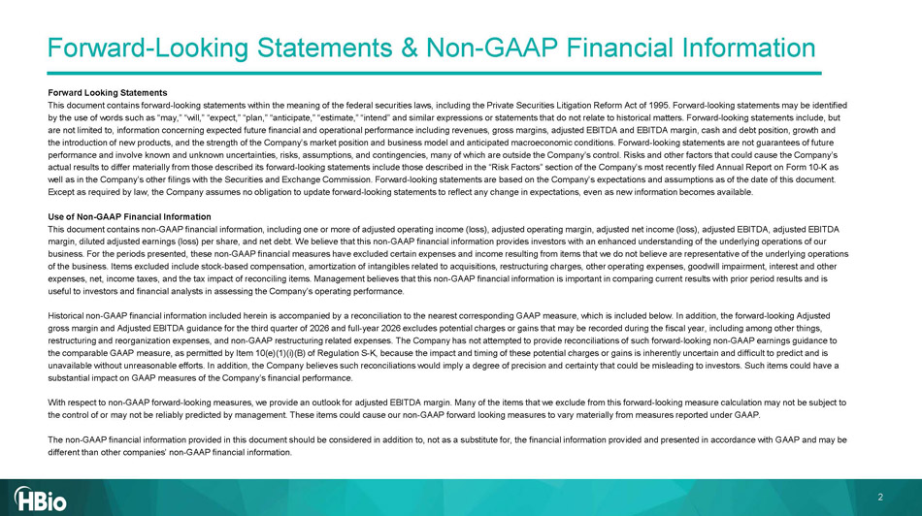
2 Forward - Looking Statements & Non - GAAP Financial Information Forward Looking Statements This document contains forward - looking statements within the meaning of the federal securities laws, including the Private Secur ities Litigation Reform Act of 1995. Forward - looking statements may be identified by the use of words such as “may,” “will,” “expect,” “plan,” “anticipate,” “estimate,” “intend” and similar expressions or st ate ments that do not relate to historical matters. Forward - looking statements include, but are not limited to, information concerning expected future financial and operational performance including revenues, gross ma rgi ns, adjusted EBITDA and EBITDA margin, cash and debt position, growth and the introduction of new products, and the strength of the Company’s market position and business model and anticipated macroe con omic conditions. Forward - looking statements are not guarantees of future performance and involve known and unknown uncertainties, risks, assumptions, and contingencies, many of which are outside the Co mpany’s control. Risks and other factors that could cause the Company’s actual results to differ materially from those described its forward - looking statements include those described in the “Risk Fac tors” section of the Company’s most recently filed Annual Report on Form 10 - K as well as in the Company’s other filings with the Securities and Exchange Commission. Forward - looking statements are based on the Company’s expectations and assumptions as of the date of this document. Except as required by law, the Company assumes no obligation to update forward - looking statements to reflect any change in expec tations, even as new information becomes available. Use of Non - GAAP Financial Information This document contains non - GAAP financial information, including one or more of adjusted operating income (loss), adjusted opera ting margin, adjusted net income (loss), adjusted EBITDA, adjusted EBITDA margin, diluted adjusted earnings (loss) per share, and net debt. We believe that this non - GAAP financial information provides i nvestors with an enhanced understanding of the underlying operations of our business. For the periods presented, these non - GAAP financial measures have excluded certain expenses and income resulting from items that we do not believe are representative of the underlying operations of the business. Items excluded include stock - based compensation, amortization of intangibles related to acquisitions, restructuring charges, other operating expenses, goodwill impairment, interest and other expenses, net, income taxes, and the tax impact of reconciling items. Management believes that this non - GAAP financial informati on is important in comparing current results with prior period results and is useful to investors and financial analysts in assessing the Company’s operating performance. Historical non - GAAP financial information included herein is accompanied by a reconciliation to the nearest corresponding GAAP m easure, which is included below. In addition, the forward - looking Adjusted gross margin and Adjusted EBITDA guidance for the third quarter of 2026 and full - year 2026 excludes potential charges or gains t hat may be recorded during the fiscal year, including among other things, restructuring and reorganization expenses, and non - GAAP restructuring related expenses. The Company has not attempted to provide reconciliations of such forward - looking non - GAAP earnings guidance to the comparable GAAP measure, as permitted by Item 10(e)(1)( i )(B) of Regulation S - K, because the impact and timing of these potential charges or gains is inherently uncertain and difficult to predict and is unavailable without unreasonable efforts. In addition, the Company believes such reconciliations would imply a degree of prec isi on and certainty that could be misleading to investors. Such items could have a substantial impact on GAAP measures of the Company’s financial performance. With respect to non - GAAP forward - looking measures, we provide an outlook for adjusted EBITDA margin. Many of the items that we e xclude from this forward - looking measure calculation may not be subject to the control of or may not be reliably predicted by management. These items could cause our non - GAAP forward looking measures to vary materially from measures reported under GAAP. The non - GAAP financial information provided in this document should be considered in addition to, not as a substitute for, the f inancial information provided and presented in accordance with GAAP and may be different than other companies’ non - GAAP financial information.


“Accelerating drug development through human - relevant translational tools” Vision 3

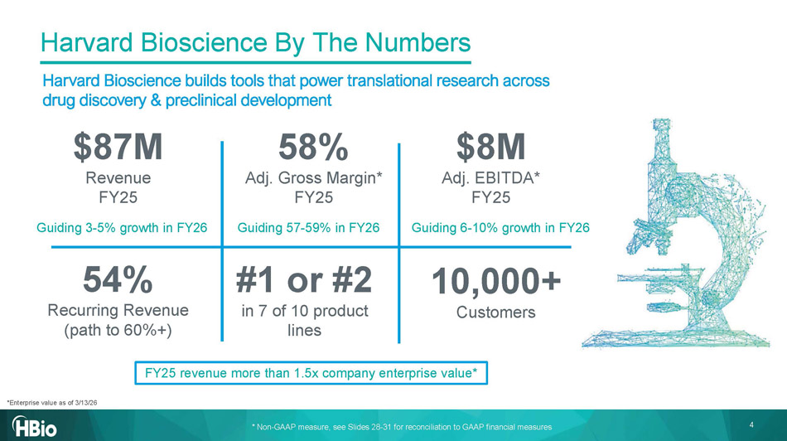
Harvard Bioscience By The Numbers $ 87 M Revenue FY25 58 % Adj. Gross Margin * FY25 $ 8M Adj . EBITDA * FY25 5 4 % R ecurring R evenue (path to 60%+) #1 or #2 in 7 of 10 product lines 10,000+ C ustomers Harvard Bioscience builds tools that power translational research across drug discovery & preclinical development Guiding 3 - 5% growth in FY26 Guiding 57 - 59% in FY26 Guiding 6 - 10% growth in FY26 4 FY25 revenue more than 1.5x company enterprise value* *Enterprise value as of 3/13/26 * Non - GAAP measure, see Slides 28 - 31 for reconciliation to GAAP financial measures

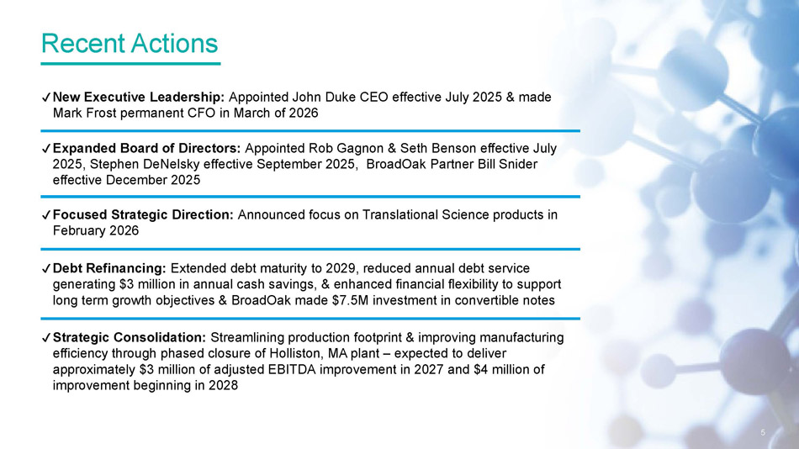
Recent Actions ✔ New Executive Leadership: Appointed John Duke CEO effective July 2025 & made Mark Frost permanent CFO in March of 2026 ✔ Debt Refinancing: E xtended debt maturity to 2029, reduced annual debt service generating $3 million in annual cash savings, & enhanced financial flexibility to support long term growth objectives & BroadOak made $7.5M investment in convertible notes ✔ Expanded Board of Directors: Appointed Rob Gagnon & Seth Benson effective July 2025, Stephen DeNelsky effective September 2025, BroadOak Partner Bill Snider effective December 2025 ✔ Strategic Consolidation: Streamlining production footprint & improving manufacturing efficiency through phased closure of Holliston, MA plant – expected to deliver approximately $3 million of adjusted EBITDA improvement in 2027 and $4 million of improvement beginning in 2028 5 ✔ Focused Strategic Direction: Announced focus on Translational Science products in February 2026

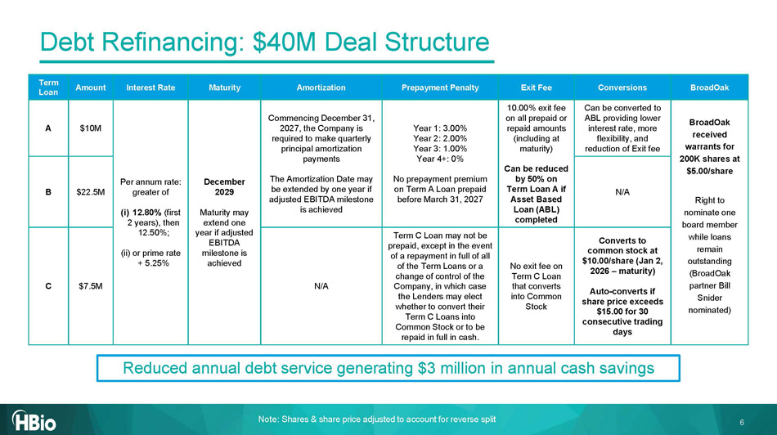
6 Debt Refinancing: $40M Deal Structure Note: Shares & share price adjusted to account for reverse split BroadOak Conversions Exit Fee Prepayment Penalty Amortization Maturity Interest Rate Amount Term Loan BroadOak received warrants for 200K shares at $5.00/share Right to nominate one board member while loans remain outstanding ( BroadOak partner Bill Snider nominated) Can be converted to ABL providing lower interest rate, more flexibility, and reduction of Exit fee 10.00% exit fee on all prepaid or repaid amounts (including at maturity) Can be reduced by 50% on Term Loan A if Asset Based Loan (ABL) completed Year 1: 3.00% Year 2: 2.00% Year 3: 1.00% Year 4+: 0% No prepayment premium on Term A Loan prepaid before March 31, 2027 Commencing December 31, 2027, the Company is required to make quarterly principal amortization payments The Amortization Date may be extended by one year if adjusted EBITDA milestone is achieved December 2029 Maturity may extend one year if adjusted EBITDA milestone is achieved Per annum rate: greater of (i) 12.80% (first 2 years), then 12.50%; (ii) or prime rate + 5.25% $10M A N/A $22.5M B Converts to common stock at $10.00/share (Jan 2, 2026 – maturity) Auto - converts if share price exceeds $15.00 for 30 consecutive trading days No exit fee on Term C Loan that converts into Common Stock Term C Loan may not be prepaid, except in the event of a repayment in full of all of the Term Loans or a change of control of the Company, in which case the Lenders may elect whether to convert their Term C Loans into Common Stock or to be repaid in full in cash. N/A $7.5M C Reduced annual debt service generating $3 million in annual cash savings

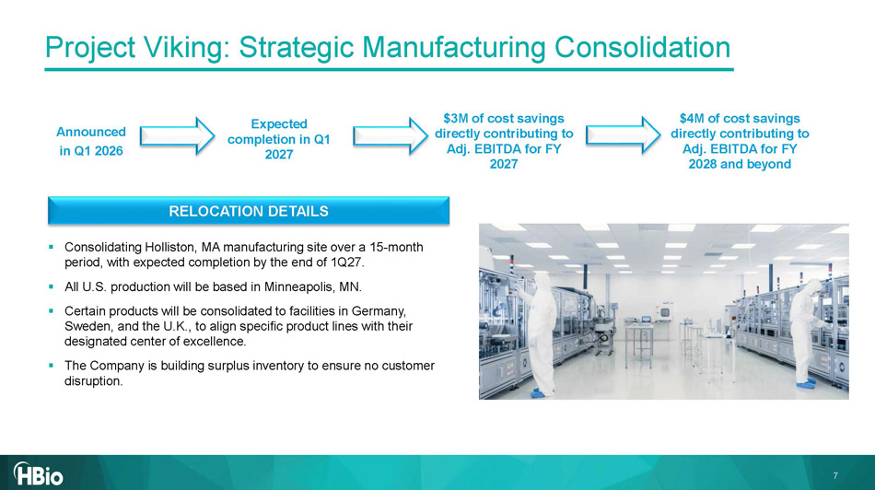
7 Project Viking: Strategic Manufacturing Consolidation Announced in Q1 2026 Expected completion in Q1 2027 $3M of cost savings directly contributing to Adj. EBITDA for FY 2027 $4M of cost savings directly contributing to Adj. EBITDA for FY 2028 and beyond ▪ Consolidating Holliston, MA manufacturing site over a 15 - month period, with expected completion by the end of 1Q27. ▪ All U.S. production will be based in Minneapolis, MN. ▪ Certain products will be consolidated to facilities in Germany, Sweden, and the U.K., to align specific product lines with their designated center of excellence. ▪ The Company is building surplus inventory to ensure no customer disruption. RELOCATION DETAILS

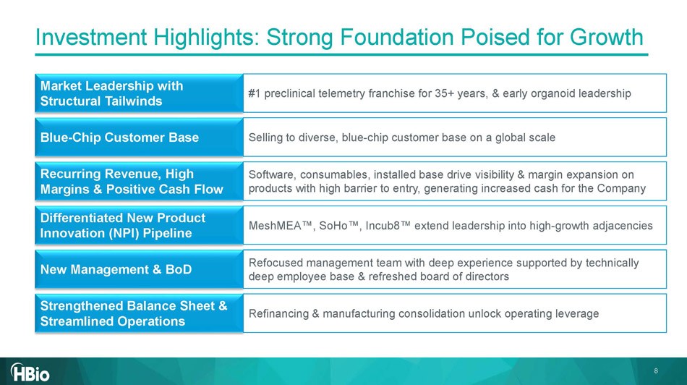
Investment Highlights: Strong Foundation Poised for Growth Market Leadership with Structural Tailwinds #1 preclinical telemetry franchise for 35+ years, & early organoid leadership Blue - Chip Customer Base Selling to diverse, blue - chip customer base on a global scale Recurring Revenue, High Margins & Positive Cash Flow Software, consumables, installed base drive visibility & margin expansion on products with high barrier to entry, generating increased cash for the Company Differentiated New Product Innovation (NPI) Pipeline MeshMEA , SoHo , Incub8 extend leadership into high - growth adjacencies New Management & BoD Refocused management team with deep experience supported by technically deep employee base & refreshed board of directors Strengthened Balance Sheet & Streamlined Operations Refinancing & manufacturing consolidation unlock operating leverage 8

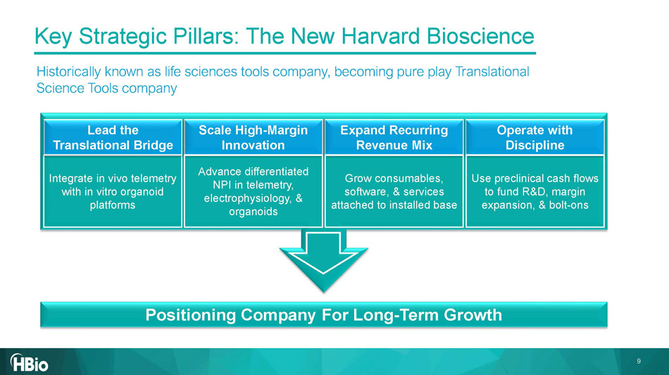
Key Strategic Pillars: The New Harvard Bioscience Historically known as life sciences tools company, becoming pure play Translational Science Tools company Positioning Company For Long - Term Growth Integrate in vivo telemetry with in vitro organoid platforms Scale High - Margin Innovation Advance differentiated NPI in telemetry, electrophysiology, & organoids Expand Recurring Revenue Mix Grow consumables, software, & services attached to installed base Operate with Discipline Use preclinical cash flows to fund R&D, margin expansion, & bolt - ons Lead the Translational Bridge 9

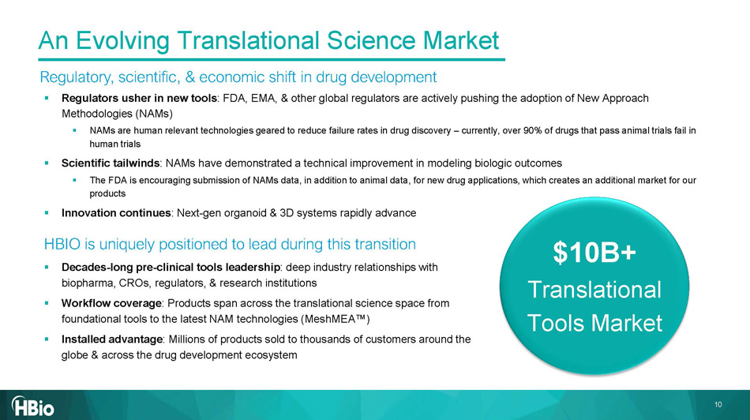
An Evolving Translational Science Market ▪ Regulators usher in new tools : FDA, EMA, & other global regulators are actively pushing the adoption of New Approach Methodologies (NAMs) ▪ NAMs are human relevant technologies geared to reduce failure rates in drug discovery – currently, over 90% of drugs that pass a nimal trials fail in human trials ▪ Scientific tailwinds : NAMs have demonstrated a technical improvement in modeling biologic outcomes ▪ The FDA is encouraging submission of NAMs data, in addition to animal data, for new drug applications, which creates an addit ion al market for our products ▪ Innovation continues : Next - gen organoid & 3D systems rapidly advance HBIO is uniquely positioned to lead during this transition ▪ Decades - long pre - clinical tools leadership : deep industry relationships with biopharma, CROs, regulators, & research institutions ▪ Workflow coverage : Products span across the translational science space from foundational tools to the latest NAM technologies ( MeshMEA ) ▪ Installed advantage : Millions of products sold to thousands of customers around the globe & across the drug development ecosystem Regulatory, scientific, & economic shift in drug development $10B+ Translational Tools Market 10

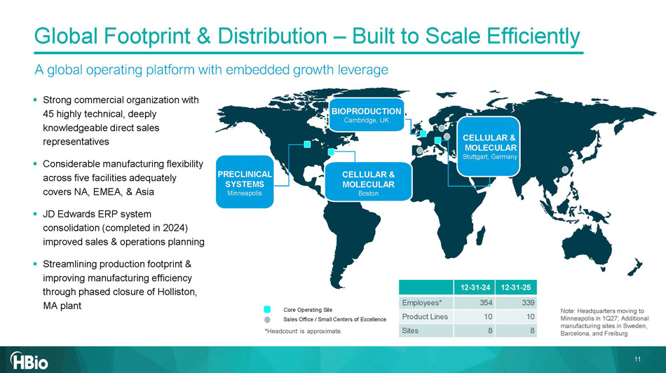
CELLULAR & MOLECULA R Boston PRECLINICAL SYSTEMS Minneapolis Core Operating Site Sales Office / Small Centers of Excellence *Headcount is approximate. Note: Headquarters moving to Minneapolis in 1Q27; Additional manufacturing sites in Sweden, Barcelona, and Freiburg 12 - 3 1 - 25 12 - 31 - 24 3 39 354 Employees* 10 10 Product Lines 8 8 Sites BIOPRODUCTION Cambridge, UK CELLULAR & MOLECULAR Stuttgart, Germany ▪ Strong commercial organization with 45 highly technical, deeply knowledgeable direct sales representatives ▪ Considerable manufacturing flexibility across five facilities adequately covers NA, EMEA, & Asia ▪ JD Edwards ERP system consolidation (completed in 2024) improved sales & operations planning ▪ Streamlining production footprint & improving manufacturing efficiency through phased closure of Holliston, MA plant A global operating platform with embedded growth leverage Global Footprint & Distribution – Built to Scale Efficiently 11

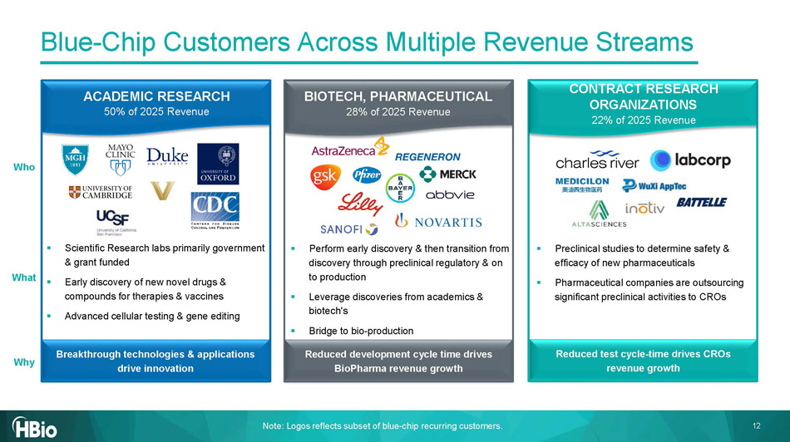
ACADEMIC RESEARCH 50% of 2025 Revenue BIOTECH, PHARMACEUTICAL 28% of 2025 Revenue Note: Logos r eflects subset of blue - chip recurring customers. ▪ Scientific Research labs primarily government & grant funded ▪ Early discovery of new novel drugs & compounds for therapies & vaccines ▪ Advanced cellular testing & gene editing ▪ Perform early discovery & then transition from discovery through preclinical regulatory & on to production ▪ Leverage discoveries from academics & biotech's ▪ Bridge to bio - production ▪ Preclinical studies to determine safety & efficacy of new pharmaceuticals ▪ Pharmaceutical companies are outsourcing significant preclinical activities to CROs Why Who What Breakthrough technologies & applications drive innovation Reduced development cycle time drives BioPharma revenue growth Reduced test cycle - time drives CROs revenue growth Blue - Chip Customers Across Multiple Revenue Streams CONTRACT RESEARCH ORGANIZATIONS 22% of 2025 Revenue 12

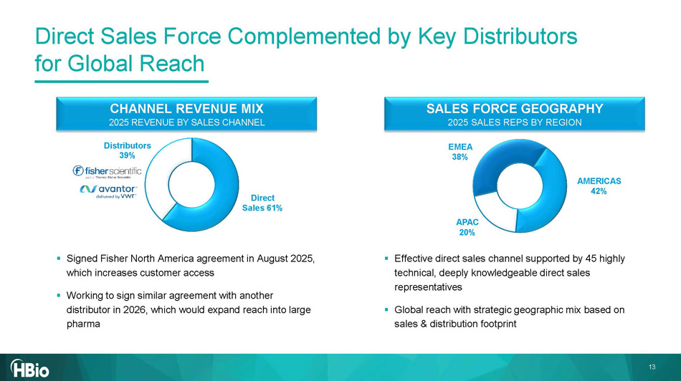
CHANNEL REVENUE MIX 2025 REVENUE BY SALES CHANNEL Direct Sales 6 1 % Distributors 3 9 % EMEA 38 % APAC 20 % SALES FORCE GEOGRAPHY 2025 SALES REPS BY REGION Direct Sales Force Complemented by Key Distributors for Global Reach ▪ Effective direct sales channel supported by 45 highly technical, deeply knowledgeable direct sales representatives ▪ Global reach with strategic geographic mix based on sales & distribution footprint ▪ Signed Fisher North America agreement in August 2025, which increases customer access ▪ Working to sign similar agreement with another distributor in 2026, which would expand reach into large pharma AMERICAS 42% 13

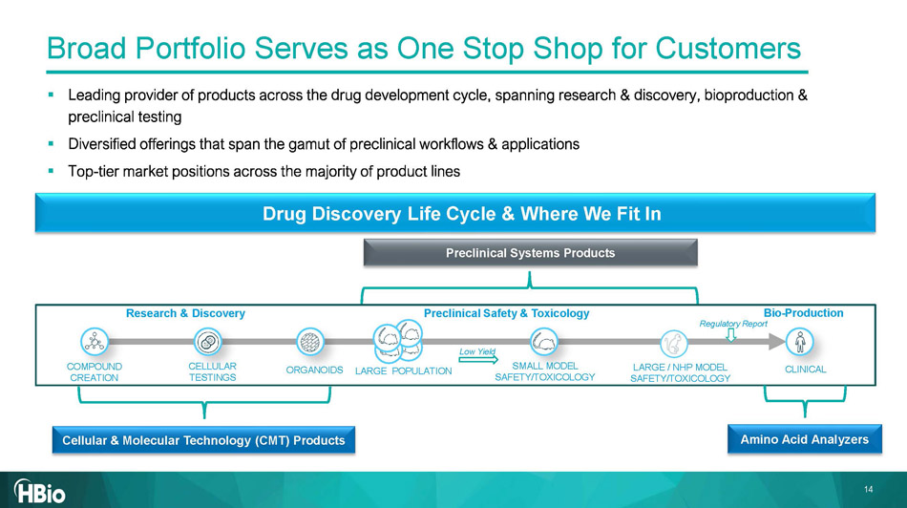
▪ Leading provider of products across the drug development cycle, spanning research & discovery, bioproduction & preclinical testing ▪ Diversified offerings that span the gamut of preclinical workflows & applications ▪ Top - tier market positions across the majority of product lines Research & Discovery Preclinical Safety & Toxicology CELLULAR TESTINGS COMPOUND CREATION CLINICAL SMALL MODEL SAFETY/TOXICOLOGY LARGE / NHP MODEL SAFETY/TOX ICOLOGY Bio - Production Regulatory Report Low Yield ORGANOIDS LARGE POPULATION Drug Discovery Life Cycle & Where We Fit In Preclinical Systems Products Cellular & Molecular Technology (CMT) Products Amino Acid Analyzers Broad Portfolio Serves as One Stop Shop for Customers 14

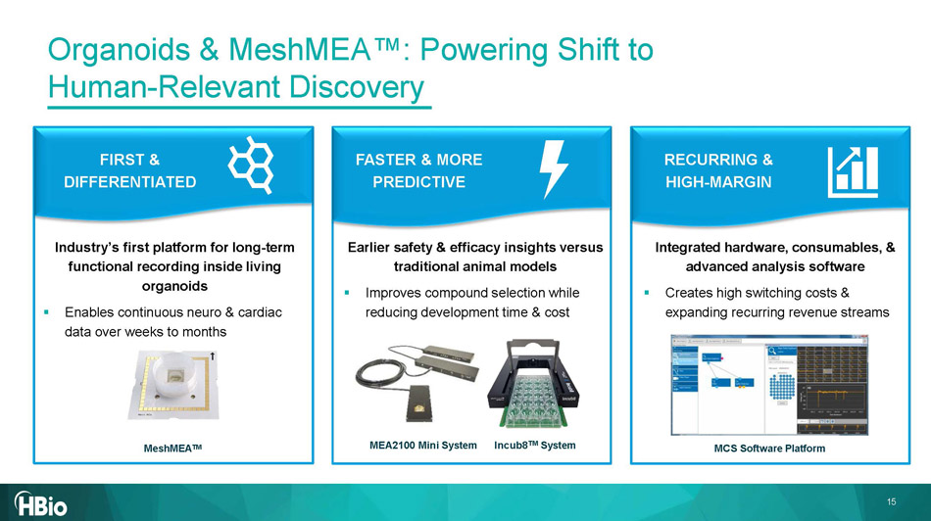
Industry’s first platform for long - term functional recording inside living organoids ▪ Enables continuous neuro & cardiac data over weeks to months Earlier safety & efficacy insights versus traditional animal models ▪ Improves compound selection while reducing development time & cost Integrated hardware, consumables, & advanced analysis software ▪ Creates high switching costs & expanding recurring revenue streams MCS Software Platform MeshMEA TM MEA2100 Mini System Organoids & MeshMEA : Powering Shift to Human - Relevant Discovery FIRST & DIFFERENTIATED FASTER & MORE PREDICTIVE RECURRING & HIGH - MARGIN Incub8 TM System 15

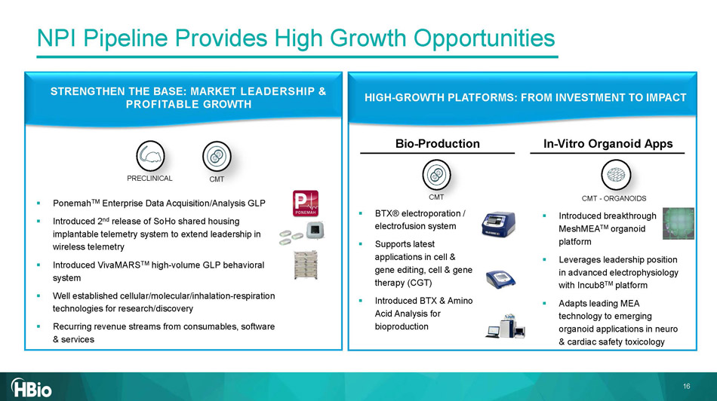
STRENGTHEN THE BASE: MARKET LEADERSHIP & PROFITABLE GROWTH HIGH - GROWTH PLATFORMS: FROM INVESTMENT TO IMPACT CMT - ORGANOIDS CMT PRECLINICAL Bio - Production In - Vitro Organoid Apps NPI Pipeline Provides High Growth Opportunities ▪ Ponemah TM Enterprise Data Acquisition/Analysis GLP ▪ Introduced 2 nd release of SoHo shared housing implantable telemetry system to extend leadership in wireless telemetry ▪ Introduced VivaMARS TM high - volume GLP behavioral system ▪ Well established cellular/molecular/inhalation - respiration technologies for research/discovery ▪ Recurring revenue streams from consumables, software & services ▪ BTX® electroporation / electrofusion system ▪ Supports latest applications in cell & gene editing, cell & gene therapy (CGT) ▪ Introduced BTX & Amino Acid Analysis for bioproduction ▪ Introduced breakthrough MeshMEA TM organoid platform ▪ Leverages leadership position in advanced electrophysiology with Incub8 TM platform ▪ Adapts leading MEA technology to emerging organoid applications in neuro & cardiac safety toxicology 16

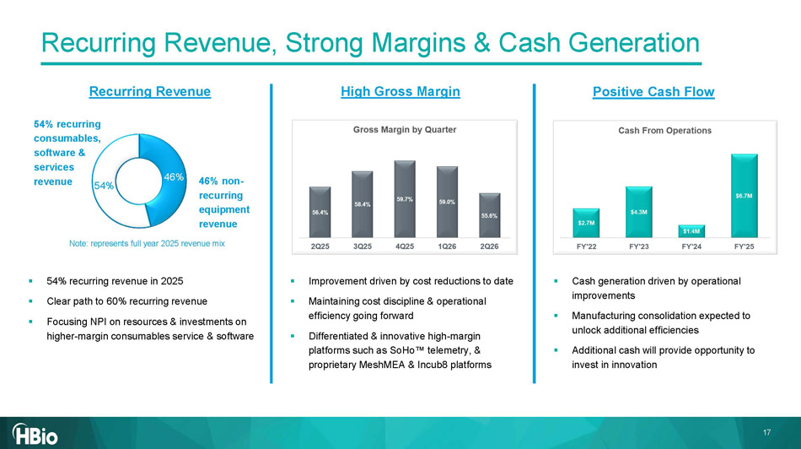
▪ 54% recurring revenue in 2025 ▪ Clear path to 60% recurring revenue ▪ Focusing NPI on resources & investments on higher - margin consumables service & software 46% 54% ▪ Improvement d riven by cost reductions to date ▪ Maintaining cost discipline & operational efficiency going forward ▪ Differentiated & innovative high - margin platforms such as SoHo telemetry, & proprietary MeshMEA & Incub8 platforms 46% non - recurring equipment revenue 54 % recurring consumables, software & services revenue Note: represents full year 2025 revenue mix ▪ Cash generation driven by operational improvements ▪ Manufacturing consolidation expected to unlock additional efficiencies ▪ Additional cash will provide opportunity to invest in innovation Recurring Revenue High Gross Margin Positive Cash Flow Recurring Revenue, Strong Margins & Cash Generation 17

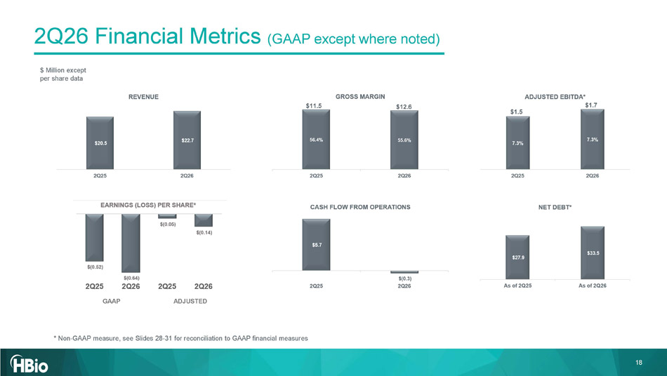
$ Million except per share data * Non - GAAP measure, see Slides 28 - 31 for reconciliation to GAAP financial measures 2Q26 Financial Metrics (GAAP except where noted) $11.5 $12.6 $1.5 $1.7 18 GAAP ADJUSTED

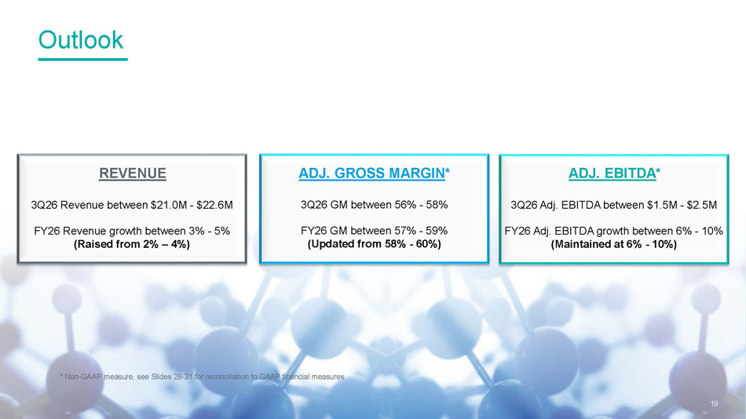
REVENUE ADJ. EBITDA * ADJ. GROSS MARGIN * 3Q26 Revenue between $21.0M - $22.6M FY26 Revenue growth between 3% - 5% (Raised from 2% – 4%) 3Q26 GM between 56% - 58% FY26 GM between 57% - 59% (Updated from 58% - 60%) 3Q26 Adj. EBITDA between $1.5M - $2.5M FY26 Adj. EBITDA growth between 6% - 10% (Maintained at 6% - 10%) Outlook 19 * Non - GAAP measure, see Slides 28 - 31 for reconciliation to GAAP financial measures

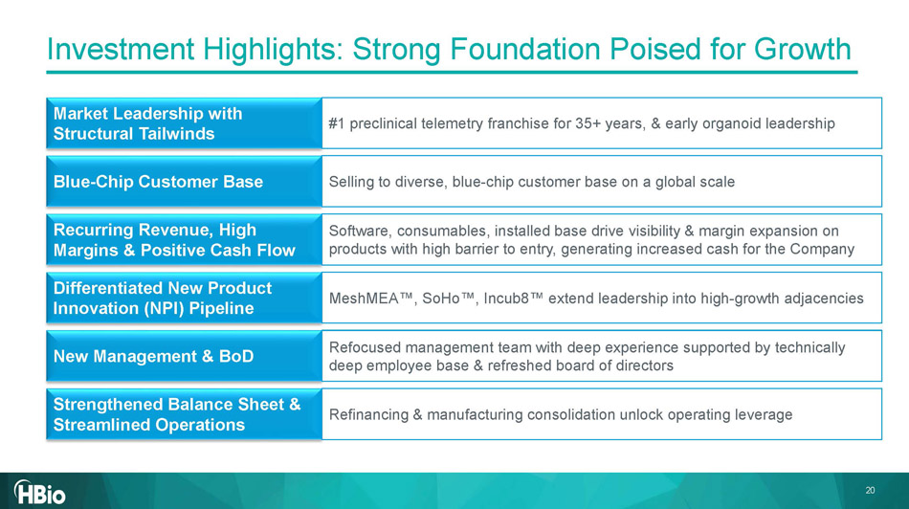
Investment Highlights: Strong Foundation Poised for Growth Market Leadership with Structural Tailwinds #1 preclinical telemetry franchise for 35+ years, & early organoid leadership Blue - Chip Customer Base Selling to diverse, blue - chip customer base on a global scale Recurring Revenue, High Margins & Positive Cash Flow Software, consumables, installed base drive visibility & margin expansion on products with high barrier to entry, generating increased cash for the Company Differentiated New Product Innovation (NPI) Pipeline MeshMEA , SoHo , Incub8 extend leadership into high - growth adjacencies New Management & BoD Refocused management team with deep experience supported by technically deep employee base & refreshed board of directors Strengthened Balance Sheet & Streamlined Operations Refinancing & manufacturing consolidation unlock operating leverage 20


21 Appendix 21

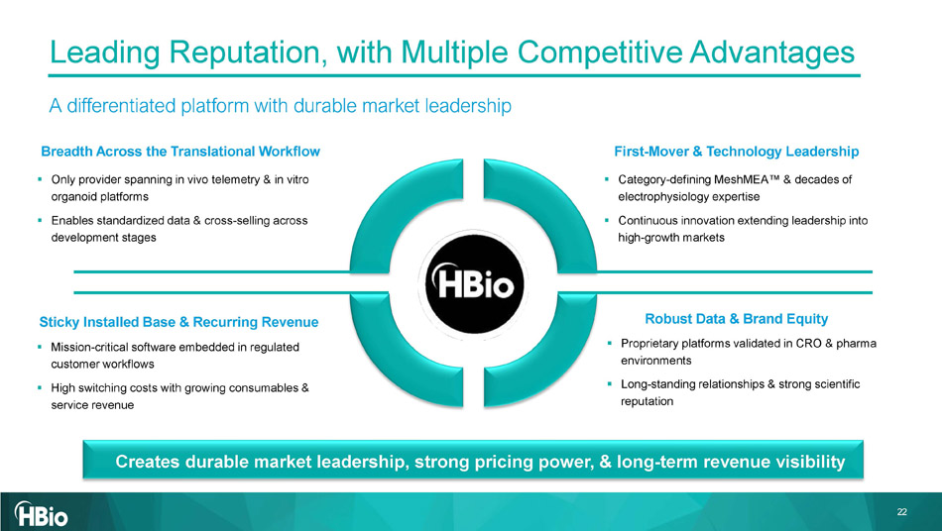
Leading Reputation , with Multiple Competitive Advantages A differentiated platform with durable market leadership 22 Breadth Across the Translational Workflow ▪ Only provider spanning in vivo telemetry & in vitro organoid platforms ▪ Enables standardized data & cross - selling across development stages Creates durable market leadership, strong pricing power, & long - term revenue visibility First - Mover & Technology Leadership ▪ Category - defining MeshMEA & decades of electrophysiology expertise ▪ Continuous innovation extending leadership into high - growth markets Sticky Installed Base & Recurring Revenue ▪ Mission - critical software embedded in regulated customer workflows ▪ High switching costs with growing consumables & service revenue Robust Data & Brand Equity ▪ Proprietary platforms validated in CRO & pharma environments ▪ Long - standing relationships & strong scientific reputation

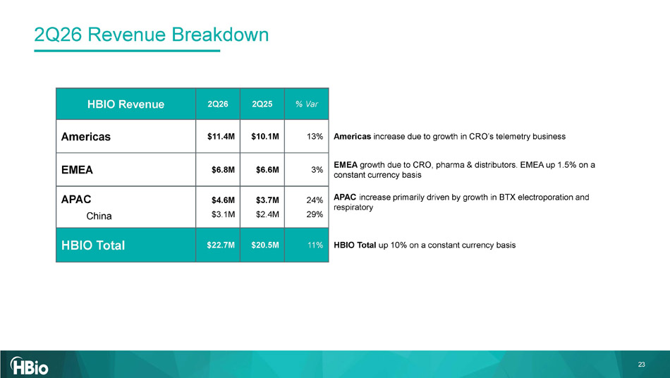
23 2Q26 Revenue Breakdown % Var 2Q25 2Q26 HBIO Revenue Americas increase due to growth in CRO’s telemetry business 13% $10.1M $11.4M Americas EMEA growth due to CRO, pharma & distributors. EMEA up 1.5% on a constant currency basis 3% $6.6M $6.8M EMEA APAC increase primarily driven by growth in BTX electroporation and respiratory 24% 29% $3.7M $2.4M $4.6M $3.1M APAC China HBIO Total up 10% on a constant currency basis 11% $20.5M $22.7M HBIO Total

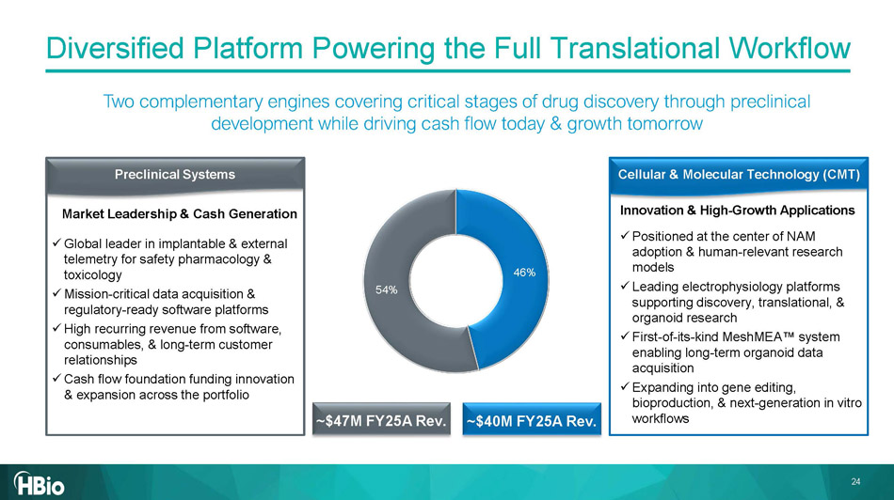
x Global leader in implantable & external telemetry for safety pharmacology & toxicology x Mission - critical data acquisition & regulatory - ready software platforms x High recurring revenue from software, consumables, & long - term customer relationships x Cash flow foundation funding innovation & expansion across the portfolio x Positioned at the center of NAM adoption & human - relevant research models x Leading electrophysiology platforms supporting discovery, translational, & organoid research x First - of - its - kind MeshMEA system enabling long - term organoid data acquisition x Expanding into gene editing, bioproduction, & next - generation in vitro workflows Cellular & Molecular Technology (CMT) Innovation & High - Growth Applications Preclinical Systems Market Leadership & Cash Generation ~$4 0 M FY2 5 A Rev. ~$4 7 M FY2 5 A Rev. Diversified Platform Powering the Full Translational Workflow Two complementary engines covering critical stages of drug discovery through preclinical development while driving cash flow today & growth tomorrow 46% 54% 24

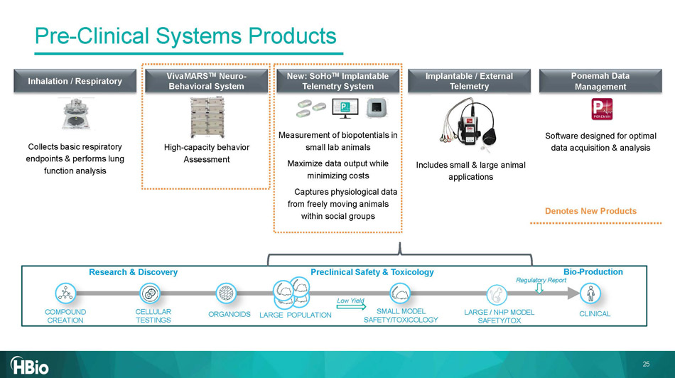
Research & Discovery Preclinical Safety & Toxicology CELLULAR TESTINGS COMPOUND CREATION CLINICAL SMALL MODEL SAFETY/TOXICOLOGY LARGE / NHP MODEL SAFETY/TOX Bio - Production Regulatory Report Low Yield ORGANOIDS LARGE POPULATION Inhalation / Respiratory VivaMARS TM Neuro - Behavioral System New: SoHo TM Implantable Telemetry System Implantable / External Telemetry Collects basic respiratory endpoints & performs lung function analysis High - capacity behavior Assessment Measurement of biopotentials in small lab animals Maximize data output while minimizing costs Captures physiological data from freely moving animals within social groups Includes small & large animal applications Ponemah Data Management Software designed for optimal data acquisition & analysis Denotes New Products Pre - Clinical Systems Products 25

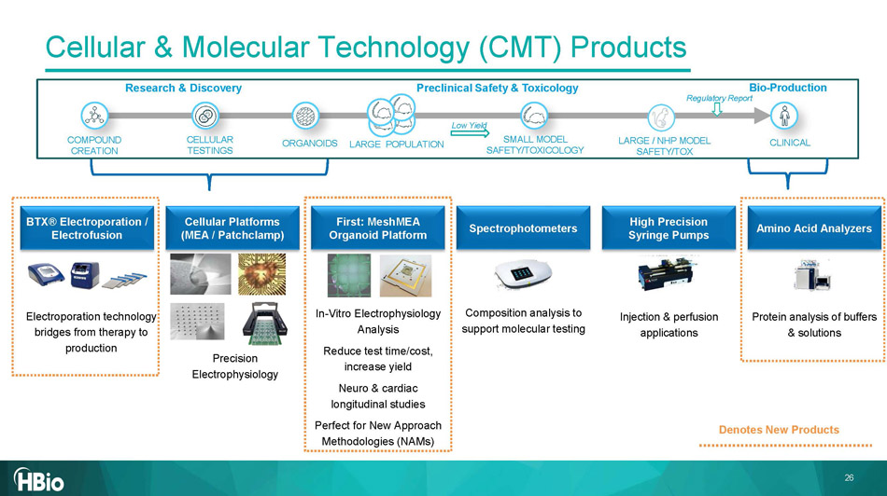
Research & Discovery Preclinical Safety & Toxicology CELLULAR TESTINGS COMPOUND CREATION CLINICAL SMALL MODEL SAFETY/TOXICOLOGY LARGE / NHP MODEL SAFETY/TOX Bio - Production Regulatory Report Low Yield ORGANOIDS LARGE POPULATION BTX® Electroporation / Electrofusion Electroporation technology bridges from therapy to production Cellular Platforms (MEA / Patchclamp ) Precision Electrophysiology First: MeshMEA Organoid Platform In - Vitro Electrophysiology Analysis Reduce test time/cost, increase yield Neuro & cardiac longitudinal studies Perfect for New Approach Methodologies (NAMs) Spectrophotometers Composition analysis to support molecular testing High Precision Syringe Pumps Injection & perfusion applications Amino Acid Analyzers Protein analysis of buffers & solutions Denotes New Products Cellular & Molecular Technology (CMT) Products 26


27 Non - GAAP Reconciliation Tables 27

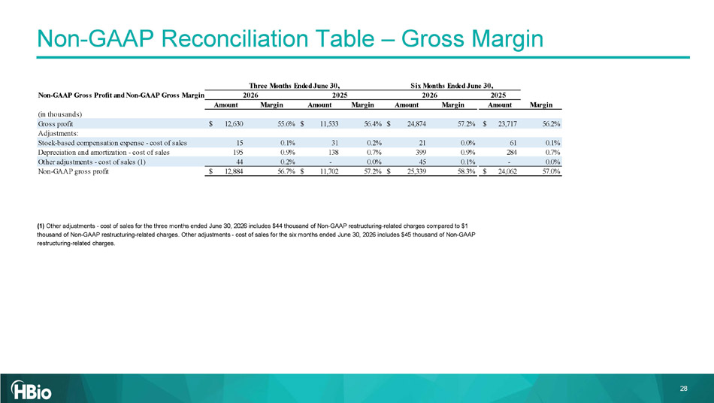
28 (1) Other adjustments - cost of sales for the three months ended June 30, 2026 includes $44 thousand of Non - GAAP restructuring - relat ed charges compared to $1 thousand of Non - GAAP restructuring - related charges. Other adjustments - cost of sales for the six months ended June 30, 2026 inc ludes $45 thousand of Non - GAAP restructuring - related charges. Non - GAAP Reconciliation Table – Gross Margin Non-GAAP Gross Profit and Non-GAAP Gross Margin Amount Margin Amount Margin Amount Margin Amount Margin (in thousands) Gross profit 12,630$ 55.6% 11,533$ 56.4% 24,874$ 57.2% 23,717$ 56.2% Adjustments: Stock-based compensation expense - cost of sales 15 0.1% 31 0.2% 21 0.0% 61 0.1% Depreciation and amortization - cost of sales 195 0.9% 138 0.7% 399 0.9% 284 0.7% Other adjustments - cost of sales (1) 44 0.2% - 0.0% 45 0.1% - 0.0% Non-GAAP gross profit 12,884$ 56.7% 11,702$ 57.2% 25,339$ 58.3% 24,062$ 57.0% 2026 2025 2026 2025 Three Months Ended June 30, Six Months Ended June 30,

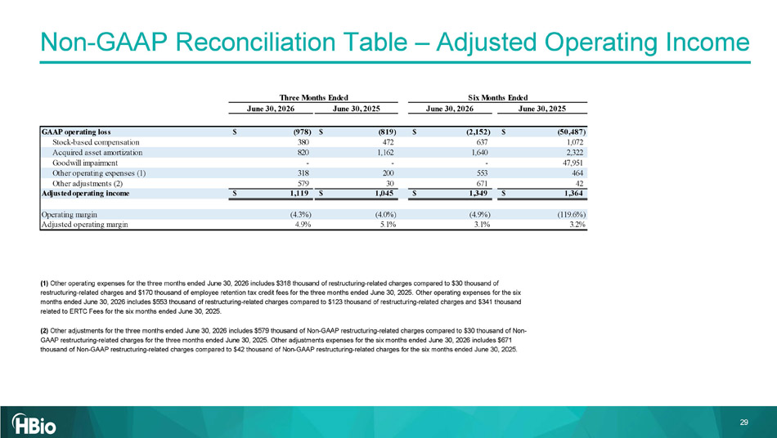
29 Non - GAAP Reconciliation Table – Adjusted Operating Income (1) Other operating expenses for the three months ended June 30, 2026 includes $318 thousand of restructuring - related charges compar ed to $30 thousand of restructuring - related charges and $170 thousand of employee retention tax credit fees for the three months ended June 30, 2025. Other operating expenses for the six months ended June 30, 2026 includes $553 thousand of restructuring - related charges compared to $123 thousand of restructuring - re lated charges and $341 thousand related to ERTC Fees for the six months ended June 30, 2025. (2) Other adjustments for the three months ended June 30, 2026 includes $579 thousand of Non - GAAP restructuring - related charges comp ared to $30 thousand of Non - GAAP restructuring - related charges for the three months ended June 30, 2025. Other adjustments expenses for the six months ended June 30, 2026 includes $671 thousand of Non - GAAP restructuring - related charges compared to $42 thousand of Non - GAAP restructuring - related charges for the si x months ended June 30, 2025. June 30, 2026 June 30, 2025 June 30, 2026 June 30, 2025 (978)$ (819)$ (2,152)$ (50,487)$ Stock-based compensation 380 472 637 1,072 Acquired asset amortization 820 1,162 1,640 2,322 Goodwill impairment - - - 47,951 Other operating expenses (1) 318 200 553 464 Other adjustments (2) 579 30 671 42 Adjusted operating income 1,119$ 1,045$ 1,349$ 1,364$ Operating margin (4.3%) (4.0%) (4.9%) (119.6%) Adjusted operating margin 4.9% 5.1% 3.1% 3.2% GAAP operating loss Three Months Ended Six Months Ended

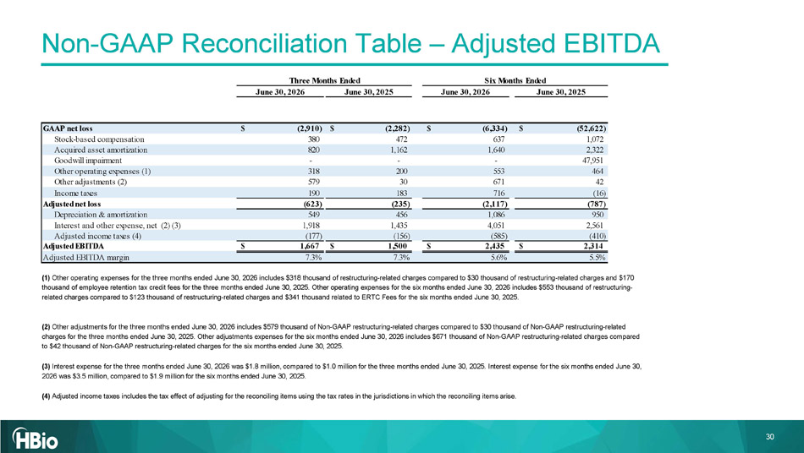
30 (1) Other operating expenses for the three months ended June 30, 2026 includes $318 thousand of restructuring - related charges compar ed to $30 thousand of restructuring - related charges and $170 thousand of employee retention tax credit fees for the three months ended June 30, 2025. Other operating expenses for the six mo nths ended June 30, 2026 includes $553 thousand of restructuring - related charges compared to $123 thousand of restructuring - related charges and $341 thousand related to ERTC Fees for the six mo nths ended June 30, 2025. (2) Other adjustments for the three months ended June 30, 2026 includes $579 thousand of Non - GAAP restructuring - related charges comp ared to $30 thousand of Non - GAAP restructuring - related charges for the three months ended June 30, 2025. Other adjustments expenses for the six months ended June 30, 2026 includes $67 1 thousand of Non - GAAP restructuring - related charges compared to $42 thousand of Non - GAAP restructuring - related charges for the six months ended June 30, 2025. (3) Interest expense for the three months ended June 30, 2026 was $1.8 million, compared to $1.0 million for the three months end ed June 30, 2025. Interest expense for the six months ended June 30, 2026 was $3.5 million, compared to $1.9 million for the six months ended June 30, 2025. (4) Adjusted income taxes includes the tax effect of adjusting for the reconciling items using the tax rates in the jurisdictions in which the reconciling items arise. Non - GAAP Reconciliation Table – Adjusted EBITDA June 30, 2026 June 30, 2025 June 30, 2026 June 30, 2025 (2,910)$ (2,282)$ (6,334)$ (52,622)$ Stock-based compensation 380 472 637 1,072 Acquired asset amortization 820 1,162 1,640 2,322 Goodwill impairment - - - 47,951 Other operating expenses (1) 318 200 553 464 Other adjustments (2) 579 30 671 42 Income taxes 190 183 716 (16) Adjusted net loss (623) (235) (2,117) (787) Depreciation & amortization 549 456 1,086 950 Interest and other expense, net (2) (3) 1,918 1,435 4,051 2,561 Adjusted income taxes (4) (177) (156) (585) (410) Adjusted EBITDA 1,667$ 1,500$ 2,435$ 2,314$ Adjusted EBITDA margin 7.3% 7.3% 5.6% 5.5% GAAP net loss Three Months Ended Six Months Ended

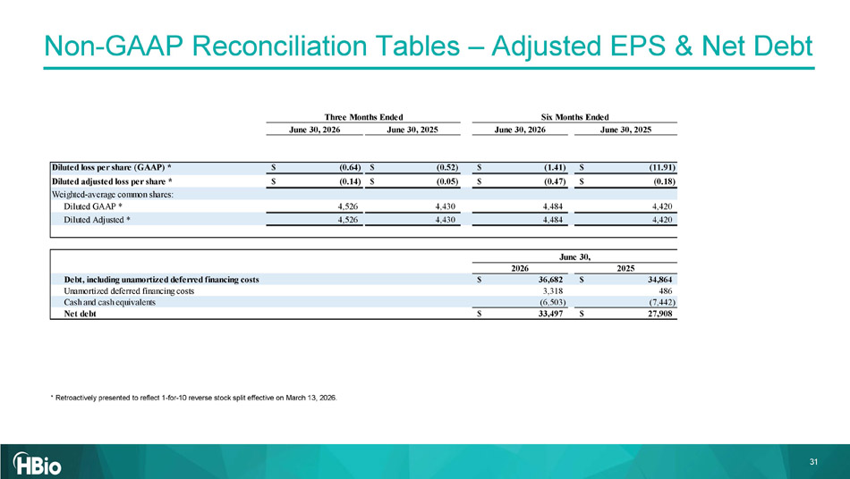
31 Non - GAAP Reconciliation Tables – Adjusted EPS & Net Debt * Retroactively presented to reflect 1 - for - 10 reverse stock split effective on March 13, 2026. June 30, 2026 June 30, 2025 June 30, 2026 June 30, 2025 Diluted loss per share (GAAP) * (0.64)$ (0.52)$ (1.41)$ (11.91)$ Diluted adjusted loss per share * (0.14)$ (0.05)$ (0.47)$ (0.18)$ Weighted-average common shares: Diluted GAAP * 4,526 4,430 4,484 4,420 Diluted Adjusted * 4,526 4,430 4,484 4,420 2026 2025 Debt, including unamortized deferred financing costs 36,682$ 34,864$ Unamortized deferred financing costs 3,318 486 Cash and cash equivalents (6,503) (7,442) Net debt 33,497$ 27,908$ June 30, Three Months Ended Six Months Ended


32

